SWECC004
Integrated comparison of leaf and soil results
Companion analysis to the SWECC004 Final report (revised, May 2026)
Natuurbegraafplaats Huis ter Heide, De Moer (Zeist)
Quercus robur — seven trees (FT01–FT03 Bokashi, NFT04–NFT06 Untreated, HT07 Healthy reference)
Nālani Balcells · Avans University of Applied Sciences · June 2026

1. Purpose and relation to the final report
This document presents an integrated comparison of all leaf and soil measurements collected for the seven study oaks at Huis ter Heide and develops a set of conclusions that draw on every substrate simultaneously. It is intended as a working document that supports the still-empty Results, Discussion, Conclusion and Recommendations chapters of the SWECC004 Final report leaves (revised version, 21 May 2026), and it follows the tree-coding (FT01–FT03 Bokashi, NFT04–NFT06 Untreated, HT07 Healthy reference) and the methodological caveats established in Chapter 3 of that report.
The leaf data come from MP-AES multi-element analysis (eight elements at two emission lines each, two technical replicate digestions per tree, recalibrated through an inverse two-line model) and from UV–Vis chlorophyll determination in 80 % acetone following Lichtenthaler & Welburn (1983), with twenty-four readings per tree. The soil data come from the parallel WECC03 soil-team work and include MP-AES on five reliable lines (Al, Mn, Cu, Zn, Fe), Hach-Lange colorimetric nitrate, phosphate and ammonium (mg kg⁻¹ dry soil), soil pH measured in KCl, CaCl₂ and demi-water, gravimetric water content (mL per ≈10 g soil, three replicates per tree), infiltration rate from double-ring infiltrometer (5–11 intervals per tree), earthworm density by mustard extraction (worms m⁻²) and fungal community indices (abundance, richness, Shannon H′, evenness J) from PDA plate counts of eleven morphotypes. All values are now read from the soil team's master workbook (Calibration curves and results.xlsx) rather than transcribed from plots. The unit of analysis is the tree (n = 3 Bokashi, n = 3 Untreated, n = 1 Healthy).
Throughout the analysis the inferential limits are taken seriously: with three trees per treatment and one healthy reference, formal significance testing is not meaningful and the patterns below are reported descriptively, in line with the stance of Section 3.7 of the Final report.

2. The integrated per-tree picture
Combining every measured indicator on a single z-score scale (Figure 1) reveals where each tree sits relative to the seven-tree mean. Two trees stand out as substantively different from the rest: the healthy reference HT07, which is above-average for leaf chlorophyll, soil nitrate, soil phosphate and soil Fe, and the bokashi tree FT01, which is the outlier of its own group on several physical and biological soil variables — much higher fungal abundance, lower infiltration, lower soil water — while its leaf chlorophyll is the lowest of the three bokashi trees. The remaining five trees show smaller deviations and overlap considerably between treatments.
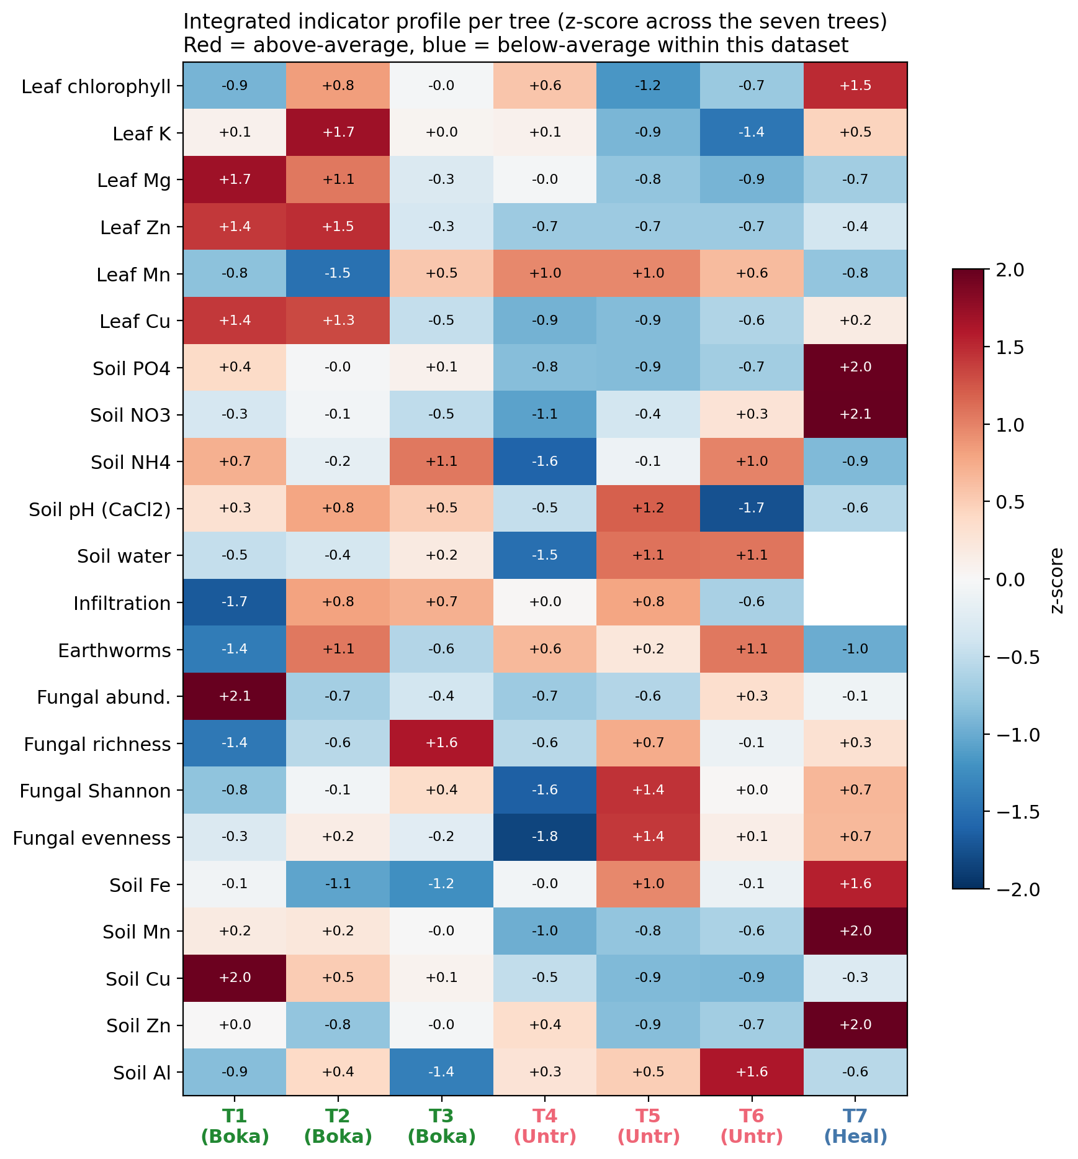
Figure 1. Integrated z-score profile of every tree against the seven-tree mean across leaf, soil-chemistry and soil-biology indicators. Red shading indicates above-average values, blue below-average. Column colour denotes treatment group.

3. Treatment-group comparison across substrates
Aggregating to the treatment level (Figure 2), four patterns emerge consistently across substrates. First, the healthy reference tree sits at or above the upper end of the bokashi range for almost every leaf and soil-chemistry indicator: leaf chlorophyll, leaf K, soil nitrate and soil phosphate are all clearly higher at HT07 than in either treated group. Second, bokashi-treated trees differ from untreated trees most clearly in soil phosphate (mean 5.0 versus 0.9 mg kg⁻¹, an approximately five- to six-fold separation that holds for every replicate pair) and in soil ammonium (7.3 versus 5.2 mg kg⁻¹), and on the leaf side in magnesium and zinc, where bokashi means exceed untreated means in every case. Third, several indicators differ very little between treatments: soil pH is uniformly strongly acidic in CaCl₂ (3.1–3.4) regardless of treatment, soil nitrate is similar between bokashi and untreated, and fungal community diversity (Shannon H′, evenness J) overlaps almost completely between the two treated groups. Fourth, and unexpectedly, earthworm density runs counter to the bokashi direction: the untreated trees average 700 worms m⁻² (range 600–800) against the bokashi mean of 467 worms m⁻² (range 200–800), and the healthy reference tree sits at the bottom of the range with 300 worms m⁻². This pattern is driven primarily by FT01 (only 200 worms m⁻², the lowest of any tree) and is consistent with FT01's other anomalies in the soil-physical data — see Section 6.
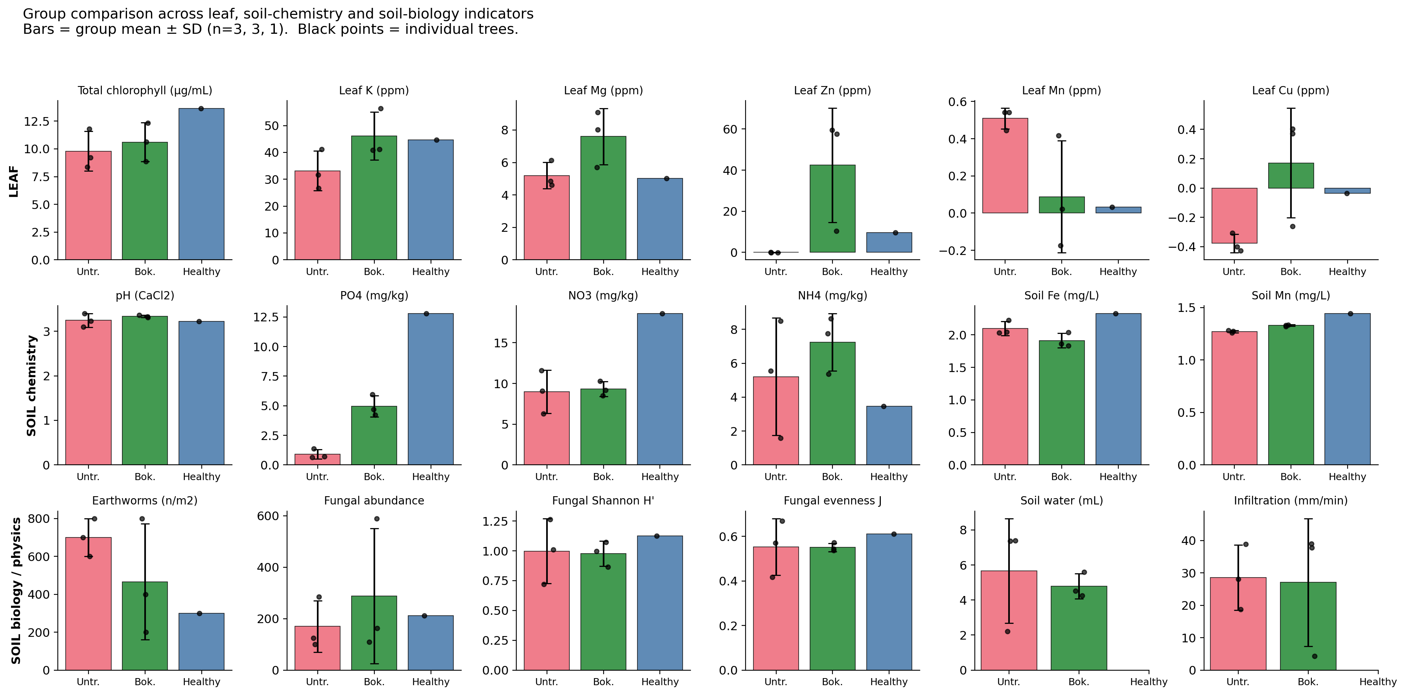
Figure 2. Group means (bar) and individual trees (points) for every leaf, soil-chemistry and soil-biology indicator. Error bars show one standard deviation (Bokashi and Untreated, n = 3; Healthy reference is a single tree shown without an error bar).

4. What the soil explains about leaf chlorophyll
Because chlorophyll concentration integrates nitrogen supply, magnesium availability and overall stress, plotting it against each soil indicator (Figure 3) provides the most direct cross-substrate diagnostic available in this dataset. At the group level the phosphate-rich bokashi soils carry the higher chlorophyll values (mean 10.6 vs 9.8 µg mL⁻¹ against soil PO₄ means of 5.0 vs 0.9 mg kg⁻¹), and the healthy reference at HT07 sits well above both treated groups on phosphate, nitrate and chlorophyll alike. Within the six treated trees, however, the tree-by-tree Pearson correlations between chlorophyll and any single soil indicator are weak and not all in the expected direction (soil PO₄ r = +0.09, soil NH₄ r = −0.51, soil NO₃ r = −0.32, soil pH r = −0.01, earthworm density r = −0.05, fungal Shannon r = −0.48), driven in particular by NFT04 — the untreated tree with the lowest soil phosphate yet the second-highest chlorophyll of any sampled tree. The bokashi signal in chlorophyll is therefore visible between treatments but is not a clean tree-level function of any one soil variable measured here.
The Shannon diversity of the soil fungal community shows essentially no relationship with chlorophyll across the treated trees, despite FT01 having by far the highest fungal abundance of any tree. This reinforces the soil-team observation that FT01’s abundance is dominated by a single morphotype — high counts do not translate into a more functional community as far as the leaf can tell.
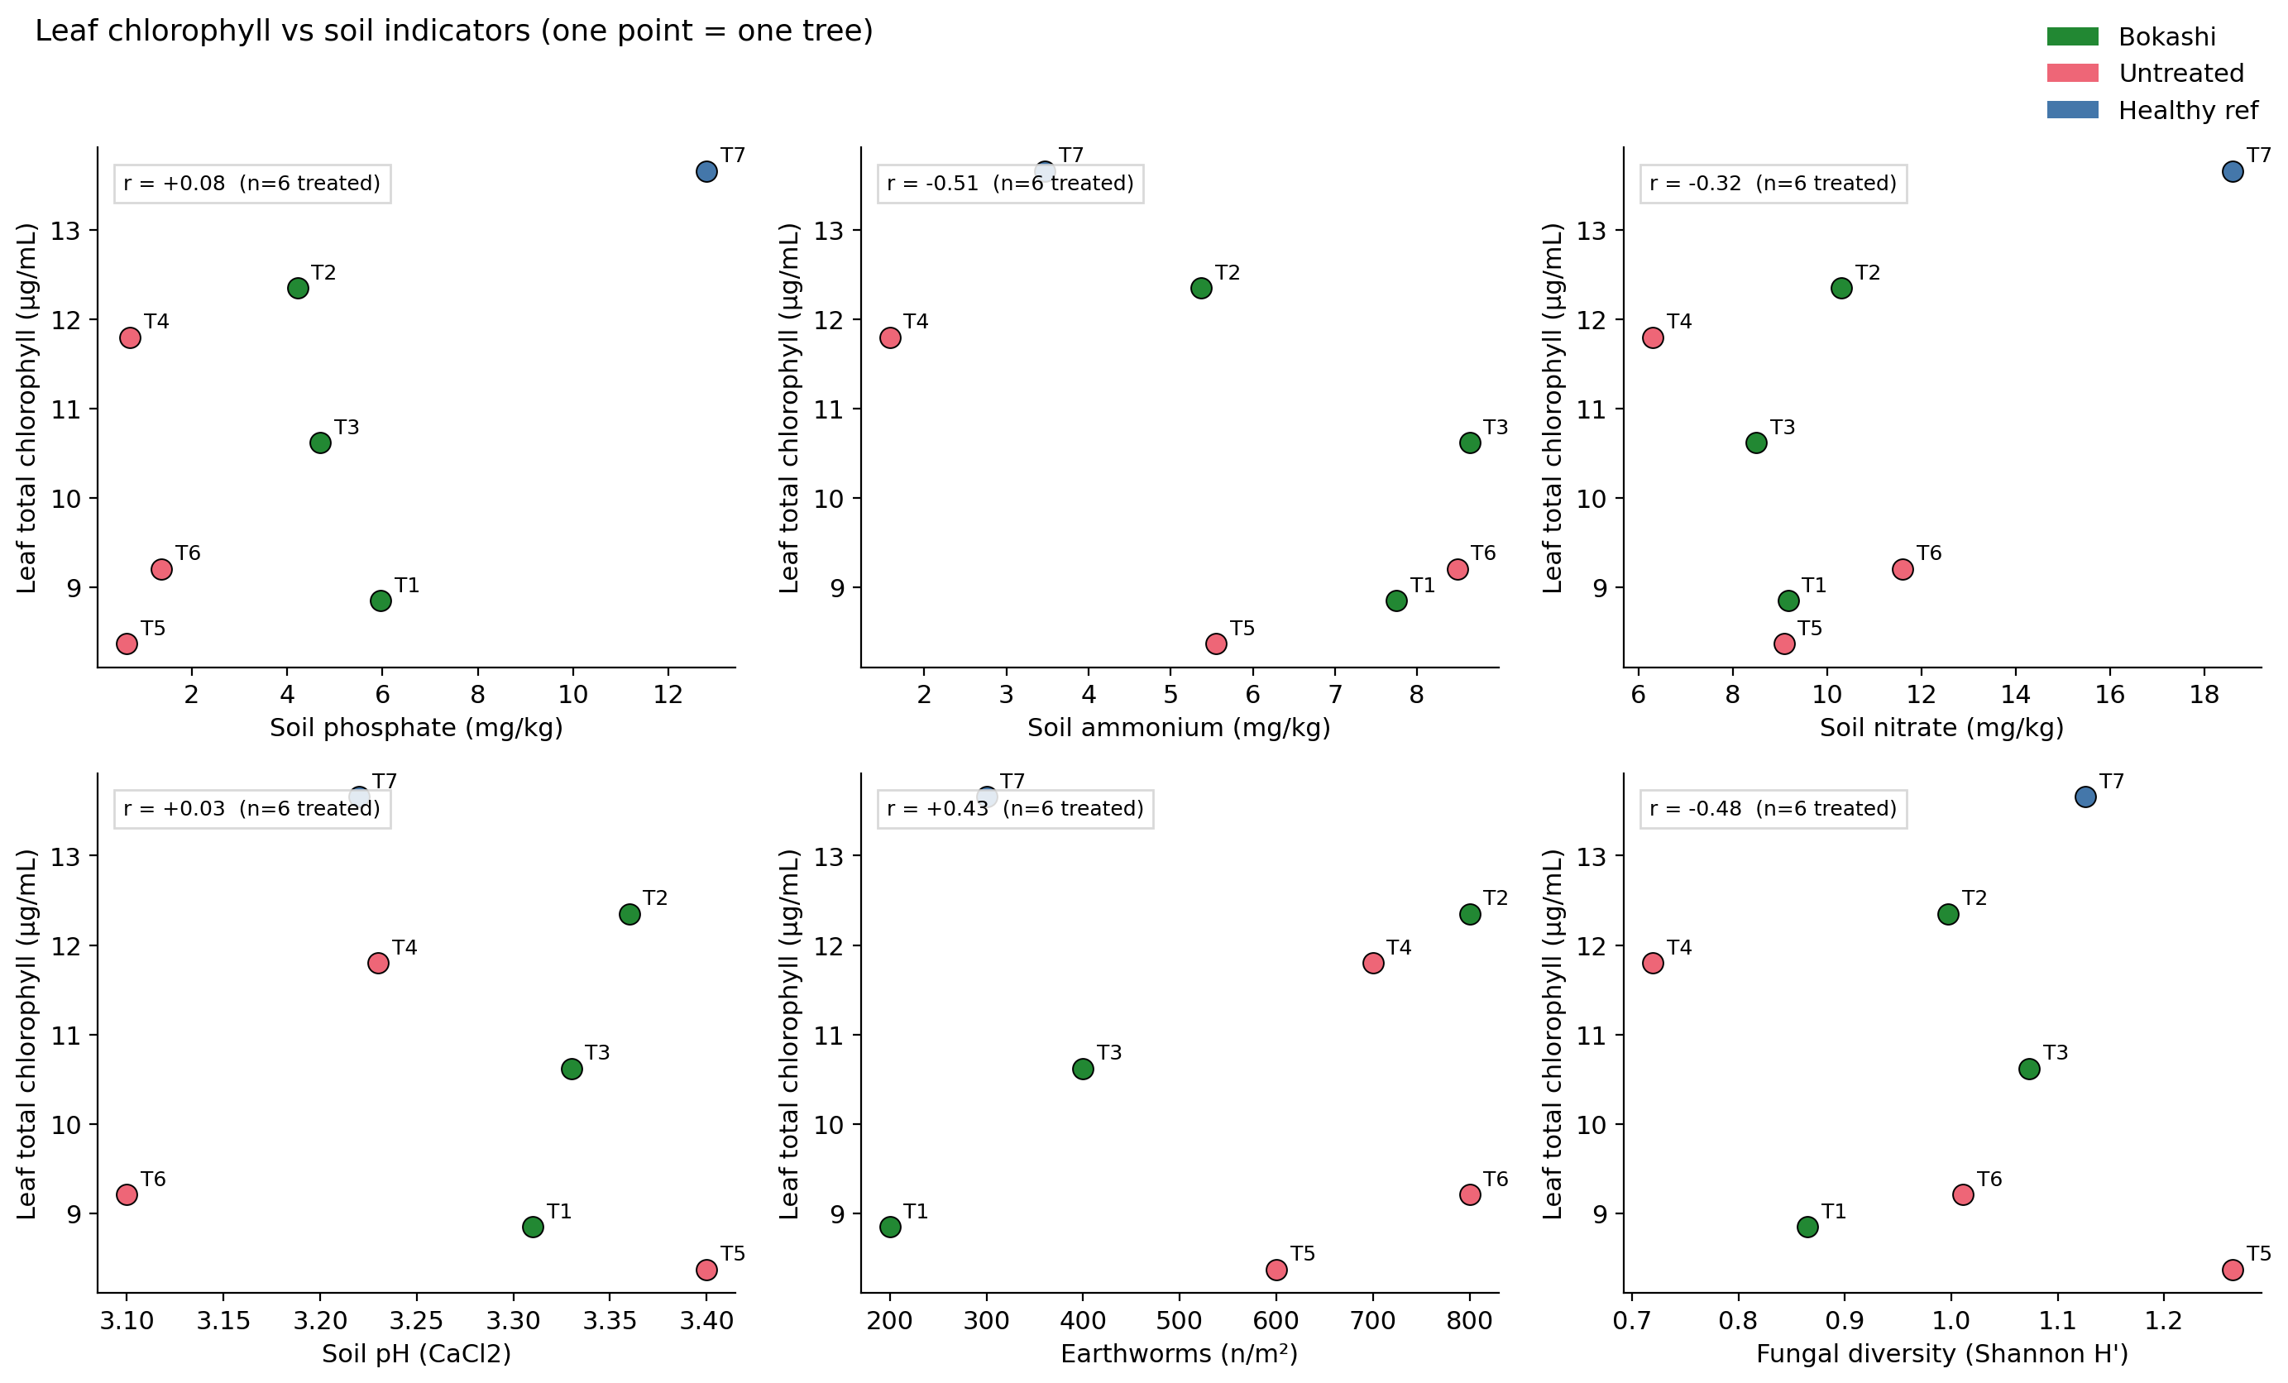
Figure 3. Leaf total chlorophyll plotted against six soil indicators. Points are individual trees; Pearson r is reported for the six treated trees only (Bokashi + Untreated). The healthy reference HT07 is shown in blue but is not included in the correlation.

5. Element-level coherence between leaf and soil
The four elements that are reliable in both substrates — Cu, Mn, Zn and Al — allow a direct test of whether the soil signal carries through to the leaf (Figure 4). For copper, leaf and soil concentrations move in the same direction across treatment: bokashi trees show higher leaf Cu and higher soil Cu than untreated trees. For zinc, leaf Zn is the most dramatically separated of any element measured (with three of three bokashi trees positive and three of three untreated trees indistinguishable from zero in the digest), while soil Zn shows only a marginal increase — an indication that the leaf concentration of Zn responds to factors beyond bulk soil Zn (most likely bioavailability mediated by pH and organic-matter complexation). Manganese and aluminium go in the opposite direction: leaf Mn is higher in untreated trees and leaf Al is much higher in untreated trees, despite soil Al being similar across treatments. Higher leaf Al in the untreated group is consistent with greater root uptake of Al³⁺ under strongly acidic conditions when no organic amendment is present to chelate it.
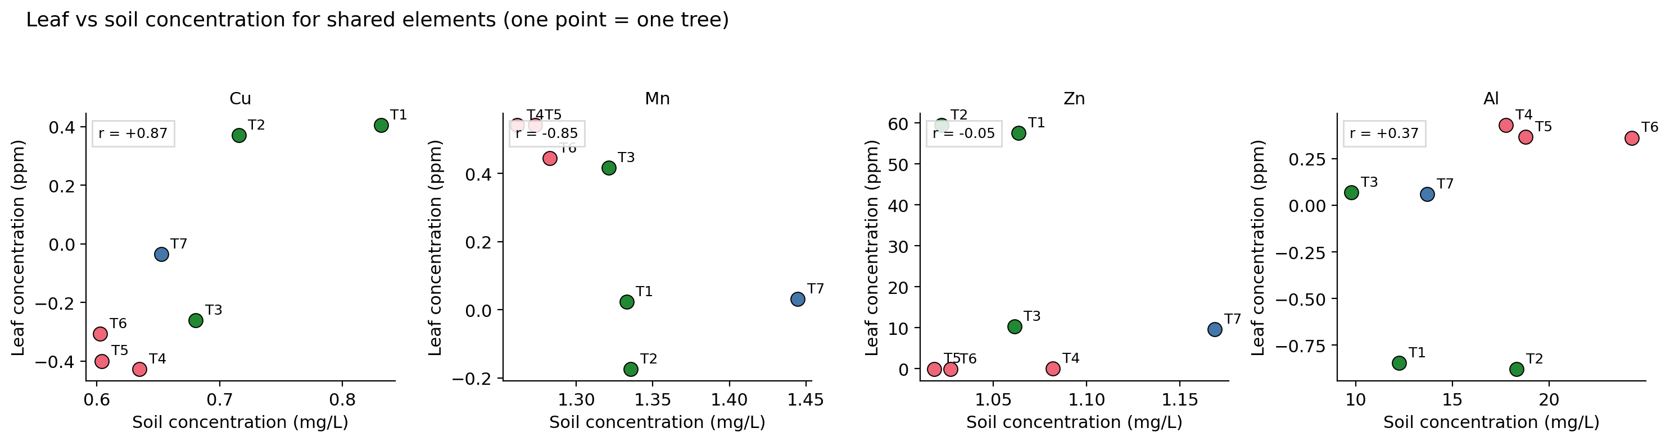
Figure 4. Leaf concentration (y-axis, ppm in digest) versus soil concentration (x-axis, mg L⁻¹ in solution) for the four elements that are reliably measured in both substrates.

6. Per-tree integrated profile
Reading the seven trees one at a time (Figure 5) makes a few important within-group differences visible that the group means smooth over. Within the bokashi group, FT02 most closely resembles the healthy reference on the leaf indicators and also has the highest earthworm density of any tree (800 m⁻²), while FT01 is the bokashi tree with the weakest leaf signal and the most anomalous soil-physical signature — very low infiltration (≈4 mm min⁻¹, an order of magnitude slower than its bokashi group-mates), low water content despite the treatment, and the lowest earthworm density of any tree (200 m⁻²). FT03 sits intermediate on the leaf indicators but has the most diverse fungal community of any tree. Within the untreated group, NFT04 has the driest soil and the lowest soil phosphate and ammonium yet a chlorophyll concentration close to that of FT02 — a useful caution against equating soil chemistry with leaf outcome at the level of individual trees. NFT06 has a notably acidic soil even by site standards (pH 3.10 CaCl₂) and the highest soil Al concentration of any tree, which is reflected in the highest leaf Al value among the untreated trees.
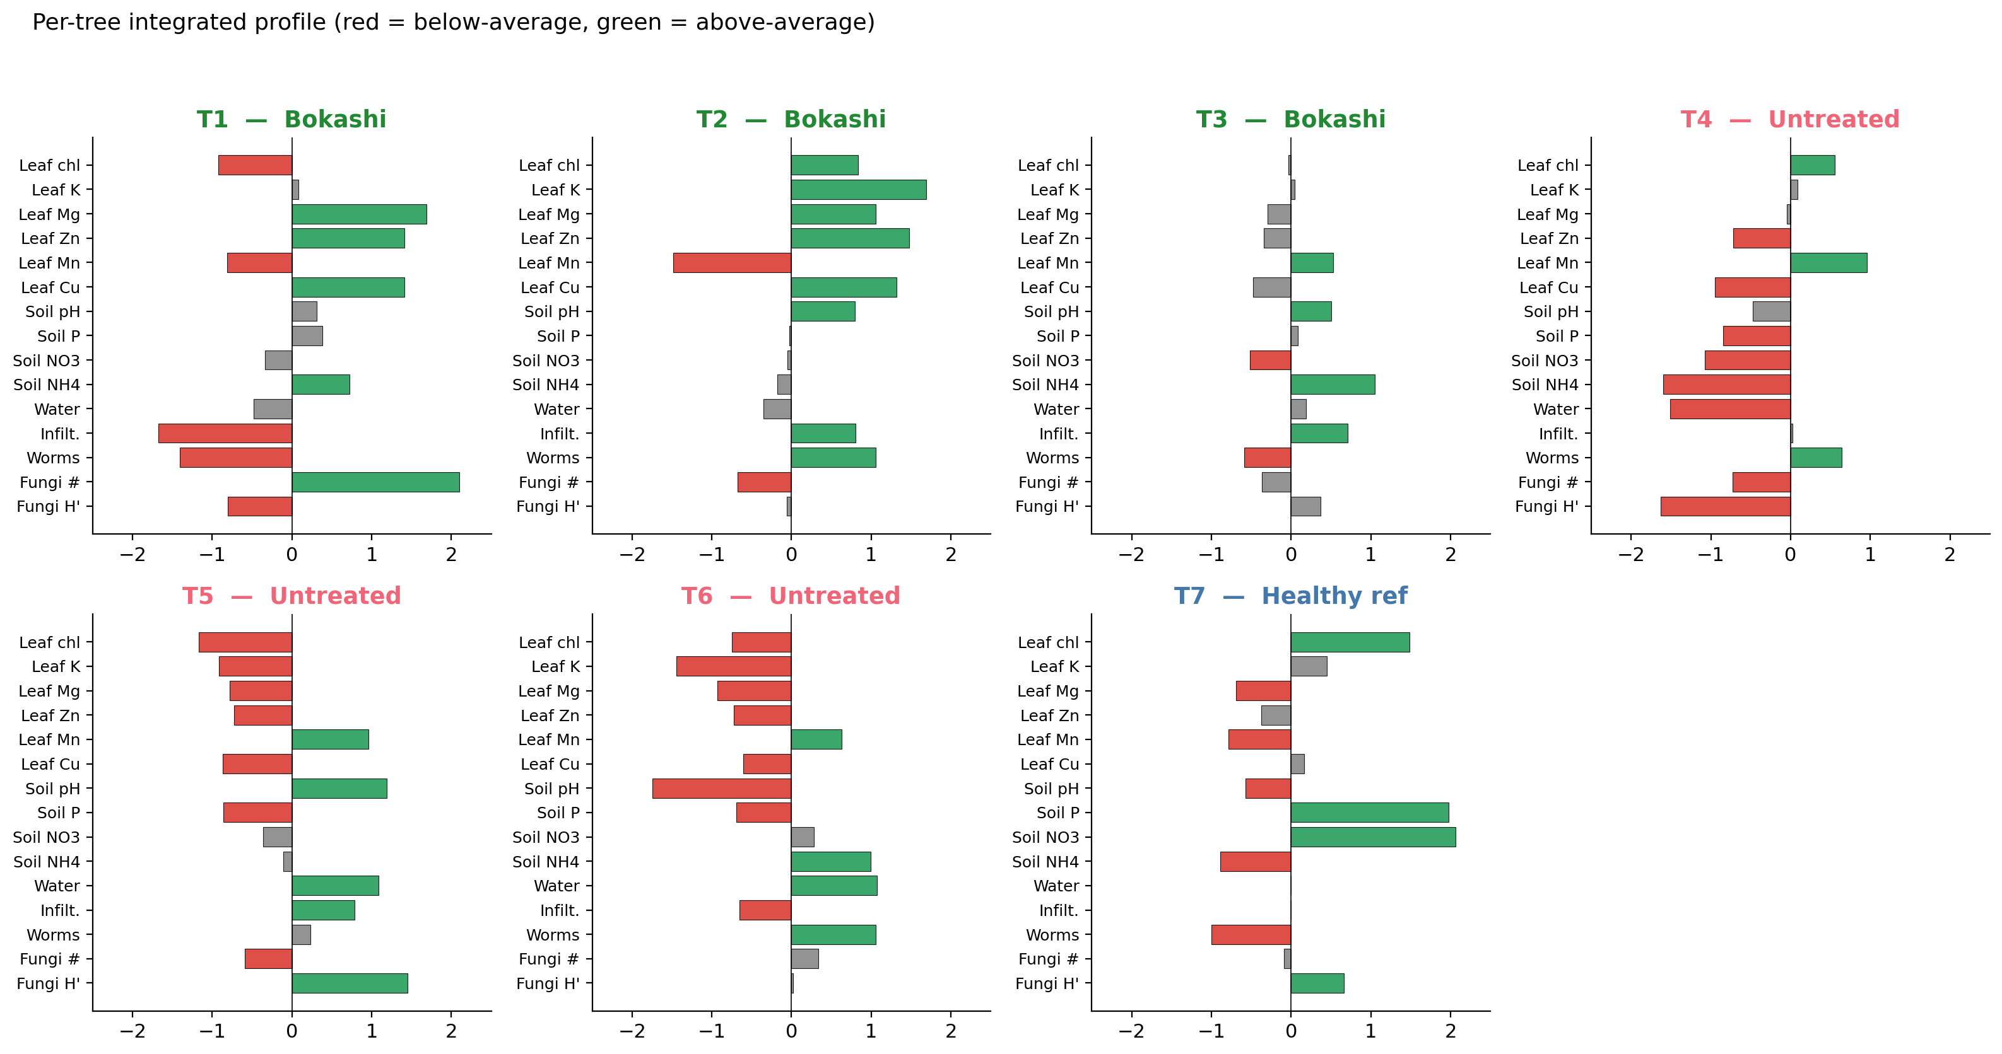
Figure 5. Per-tree integrated profile, showing each tree's deviation from the seven-tree mean for fourteen key indicators. Green bars are above-average, red below-average.

7. Indicator co-movement (exploratory)
A pairwise correlation map across all indicators (Figure 6, treated trees only) underscores a clustering structure that is consistent with the bokashi signal documented above. Soil phosphate, leaf magnesium, leaf zinc and leaf chlorophyll co-vary positively, and all four also co-vary positively with soil ammonium; leaf manganese and leaf aluminium form a counter-cluster that varies negatively with the bokashi cluster. Soil pH and fungal diversity sit largely orthogonal to both clusters, suggesting that pH does not by itself drive the leaf response within the narrow range covered by these soils. These correlations are descriptive only — six observations cannot support inference about the underlying causal structure — but they describe the same direction of effect as the group comparison in Section 3, which adds modest confidence that the bokashi signal is real and not driven by one influential tree.
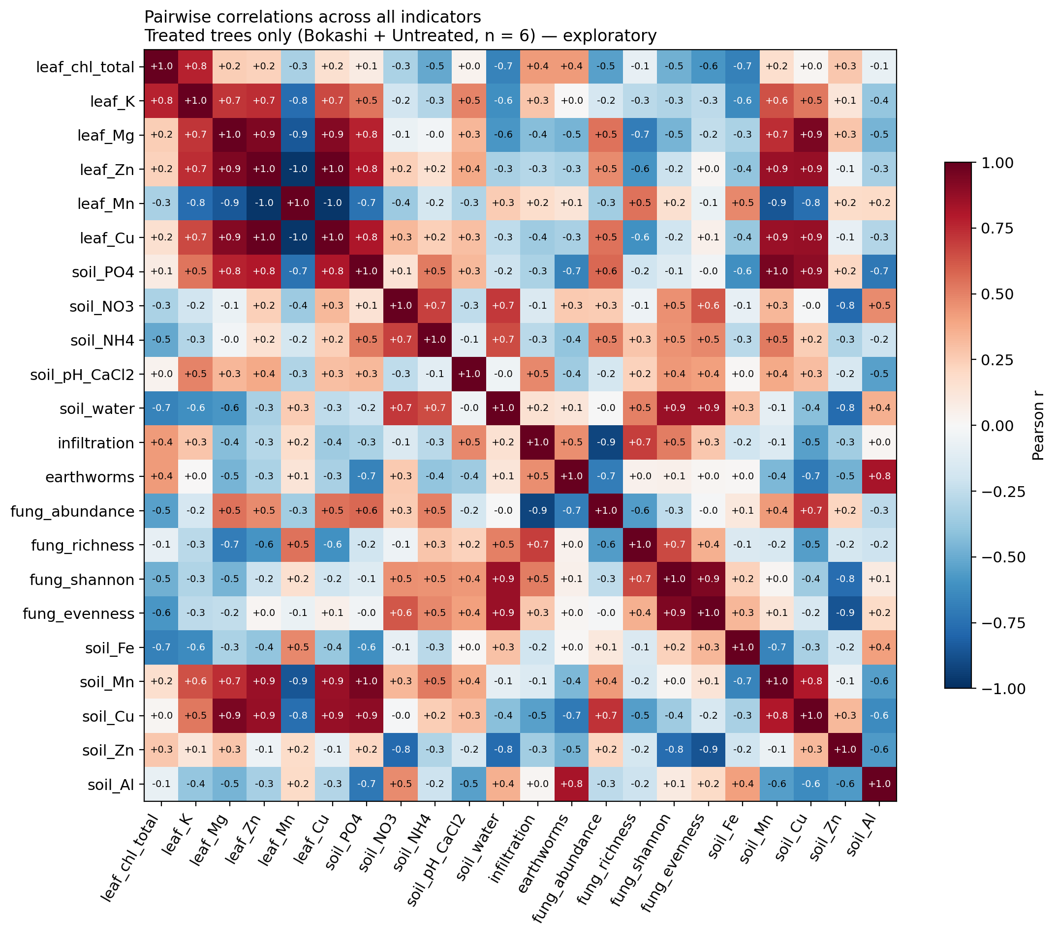
Figure 6. Pairwise Pearson correlations across all indicators, treated trees only (n = 6). Values are exploratory and not significance-tested.

8. Integrated conclusions

8.1 On the leaf nutrient status and oak vitality
Within the limits of a single-round, seven-tree dataset, the leaf nutrient status of the trees at Huis ter Heide is broadly typical of oaks growing on strongly acidic, podzol sands. Potassium and magnesium concentrations sit within the lower end of literature sufficiency ranges, calcium and iron determinations are not reliable in this campaign (over-range Ca, below-detection Fe — both flagged in the calibration), and the micronutrient picture is dominated by clear treatment effects on zinc and aluminium. The healthy reference tree has, on every reliable leaf indicator, the most favourable position of any tree in the study, which corroborates the visual basis on which it was selected and supports its use as a target benchmark.

8.2 On the effect of bokashi
Across the seven trees the most consistent bokashi signal is in the soil chemistry, not in the leaf chemistry. Bokashi-treated soils carry between four and six times more available phosphate than the matched untreated soils — every bokashi replicate exceeds every untreated replicate — and approximately 1.4 times more ammonium. These signals are clear at the level of a tree-by-tree comparison even though they cannot be defended as statistically significant at n = 3 per treatment. The leaf consequences of this soil-chemistry advantage are smaller and more selective: bokashi trees show higher leaf magnesium and zinc and slightly higher chlorophyll than untreated trees, while the converse holds for manganese and aluminium, which are characteristic of acid-stress uptake and which decrease under bokashi. Read together, these patterns are consistent with the mechanism described in Chapter 2.2 of the report — that bokashi raises organic-matter content, increases nutrient retention and tempers the acid-stress micronutrient profile — without indicating that two applications (2022 and follow-up) have yet brought treated trees up to the level of the healthy reference. The soil-chemistry signal is the strongest bokashi response in the lab data; the leaf-chemistry signal is in the expected direction but weaker. The visual crown assessment carried out in May 2026 strengthens the picture from an independent angle: averaged across the two trained observers, bokashi-treated trees showed 37.5 % crown defoliation against 59.2 % in the untreated group and 15.8 % in the healthy reference candidates — a 22-percentage-point separation in the same direction as the soil-chemistry and leaf-Mg / leaf-Zn signals. Because crown condition integrates the whole tree across the whole growing season, the visual evidence is the most ecologically meaningful single line of evidence for a positive bokashi effect at this site.

8.3 On the soil physical and biological response
Soil pH is uniformly strongly acidic across all seven trees and is not measurably modified by bokashi at this stage. Fungal community diversity (Shannon H′, evenness J) is essentially indistinguishable between treatments, with the healthy reference tree showing only marginally higher values than the within-site mean. Earthworm density runs counter to the bokashi direction: the untreated trees average 700 worms m⁻² against the bokashi mean of 467 and the healthy reference at 300. Read with the rest of the soil data, this is a reminder that earthworm density at a single time point reflects many local factors beyond bokashi application (soil moisture at sampling, recent rainfall, vegetation litter input) and that a single-round earthworm count is not, by itself, a sensitive bokashi indicator at this site. The single bokashi tree FT01 stands out separately: it combines the lowest earthworm density of any tree (200 m⁻²), the lowest infiltration (≈4 mm min⁻¹), low water content and a fungal community dominated by one morphotype — features that mark it as a within-treatment outlier in the soil-physical and biological data even though its leaf chemistry sits comfortably within the bokashi range.

8.4 Suitability of the leaf-based monitoring approach
The combination of MP-AES leaf-mineral analysis (with an inverse two-line calibration), PhotoFolia-supported chlorophyll measurement and lab-validated UV–Vis chlorophyll has produced an internally coherent dataset in which the strongest cross-substrate signals (soil phosphate, leaf Zn, leaf Mg) are visible at the tree level after a single sampling round. The approach is therefore suitable for the continued monitoring envisaged in the monitoring plan, on the understanding that two methodological refinements are necessary before the leaf data become genuinely diagnostic for individual trees: the Ca and Fe calibration must be redesigned (lower standard concentrations and a wider dilution series) so that the macronutrient Ca and the micronutrient Fe become measurable, and the n per treatment must be increased to at least five trees if formal hypothesis testing is to be attempted.

9. Recommendations
Three practical recommendations follow from the integrated picture. First, since the soil-chemistry effect of bokashi at this site is now demonstrable but the leaf effect is still subtle, continued or expanded bokashi application is justified provided a follow-up monitoring round is scheduled for the same trees in 2027 to test whether the leaf-Mg and leaf-Zn signals strengthen. Second, the very low soil phosphate of every untreated tree (median 0.6 mg kg⁻¹) suggests that phosphate availability — rather than nitrogen — is the likely binding nutrient for these oaks; a targeted phosphate-amendment trial on a subset of untreated trees would isolate this effect from the broader bokashi response. Third, the within-bokashi outlier FT01 (low infiltration, low water content, dominant single fungal morphotype) should be revisited specifically to determine whether a local soil-structural problem is masking the bokashi response at that location, since its leaf chlorophyll is the lowest of the three treated trees despite identical treatment history.
For the monitoring plan itself, the indicators that carry the most cross-substrate information per unit effort are leaf chlorophyll (24 readings per tree), leaf K + Mg + Zn (MP-AES on the existing four lines), soil phosphate and ammonium (Hach-Lange), and soil pH in CaCl₂. The fungal-diversity protocol has the lowest diagnostic yield at this sample size and could be reduced in frequency without losing the central treatment signal.

10. Limitations of the integrated comparison
Two limitations apply to every conclusion in this document. First, the design is a tree-level snapshot with three replicates per treatment and a single healthy reference, which is sufficient to describe direction of effect but not magnitude with any precision. Second, leaf Ca and leaf Fe are not analysable in this campaign — Ca exceeds the calibration range and Fe falls below detection — so any cross-substrate interpretation involving those two elements is suspended pending re-analysis under the modified calibration recommended in Section 8.4. All other soil values used here are read directly from the soil team's master workbook (Calibration curves and results.xlsx), so the integrated table is now end-to-end auditable.

Where this fits in the SWECC004 final report
Material in Sections 2–7 of this document is suitable as a basis for Section 4.4 (relationships between indicators) and Section 4.5 (comparison with soil) of the final report; the conclusions in Section 8 map directly onto Sections 5.3 (effect of bokashi) and 5.4 (comparison with soil and NDVI); and the recommendations in Section 9 expand the placeholders currently in Chapter 7. The supporting per-tree integrated table is delivered alongside this document as SWECC004_integrated_per_tree.csv.

